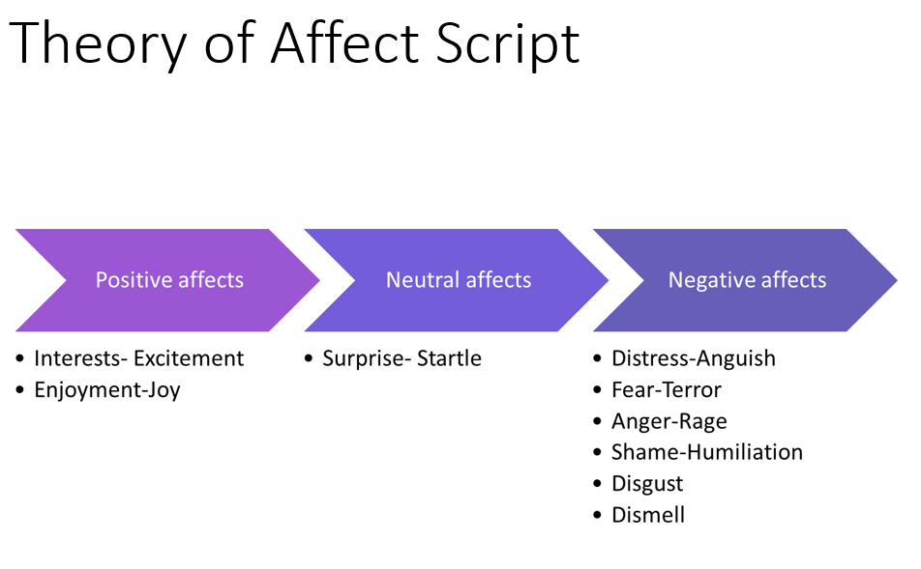

Tompkins' Theory of Affect Script:
Sylvan Tompkins, an American psychologist, proposed the theory of affect script, which posits that human emotions are organised around scripts or scenarios that guide our understanding of, and response to emotional experiences. These affect scripts are learned through socialisation and experiences, and they shape our emotional responses to various situations. Affect scripts can be positive or negative, and they influence our behaviours, decision-making, and social interactions.

Think of emotions as being like the scripts in a play. These scripts tell the actors what to do and how to feel. We all have our own set of scripts that we learn from our life experiences and the people around us, and they can be either positive or negative. Positive scripts can be like treasure maps, guiding us to joy, excitement, and happiness - things that we naturally aim for, just like a pirate aims for treasure.

Negative scripts, on the other hand, can be like thorny paths through a dark forest, leading us to feel upset, angry, or sad. These paths are tougher to walk on, and we'd rather avoid them if we can. But sometimes, if we find thorns on our way to the treasure, we might start to feel discouraged or stuck. Understanding these emotional scripts is like having a flashlight and a map - it helps us see where we are, find our way out of the dark forest, and navigate towards the treasure (or the positive emotions) more effectively.

The concept of Psychological shame
In psychological terms, shame is a complex and powerful emotion that arises when an individual perceives themselves as flawed, inadequate, or unworthy in some way. It is important to differentiate this concept of shame from the common use of the word, which often refers to feelings of embarrassment or discomfort.

Think of shame as a heavy monster that jumps on your back when you think you've made a mistake or done something wrong. This isn't just feeling embarrassed, like tripping over a stone and laughing it off. It's more like falling into a hole and feeling like you can't get out.

This shame monster whispers in your ear, making you believe that you're not good enough, that you're a bad person, and it can make you want to hide or run away. It's like having a shadow that follows you everywhere, constantly reminding you of the hole you fell into, even if it wasn't your fault.

This monster can grow so big that it weighs you down, making it hard to smile, laugh, or enjoy things. You might feel alone, as if you're stuck in a dark room while everyone else is outside playing in the sunshine. Sometimes, the shame monster can make you do things that aren't good for you, like hurting yourself or pushing people away.

Understanding shame is like learning how to switch on a light in that dark room. It can help us find ways to shrink the monster and show people that it's okay to ask for help. It's like giving them a ladder to climb out of the hole and join everyone else, where they can feel the sun on their faces again. Because everyone deserves to enjoy the party, no matter how many drinks they've spilled.

The Central Executive
Sylvan Tomkins proposed the "four basic rules" of the human central motive system. These rules are:

- Maximise positive affect: The central motive system is driven by a desire to maximise positive emotions and experiences. Like a gardener who cultivates his garden, taking care to water the plants that bring bright and beautiful flowers.

- Minimise negative affect: The system also strives to reduce negative emotions and experiences. This is akin to the same gardener promptly plucking out weeds to avoid them overshadowing the beautiful flowers.

- Minimise the inhibition of affect: Tomkins believed that suppressing or inhibiting emotions was not healthy or productive. Think of it like putting a lid on a boiling pot. The pressure keeps building up inside until it has no choice but to burst out. Instead, emotions should be acknowledged and expressed appropriately.

- Maximise the expression of affect: Lastly, Tomkins emphasised the importance of expressing emotions. By expressing our emotions, we can better understand them and manage our reactions to different situations. It's like a painter who uses his art to express his feelings. The more he paints, the better he understands what he's feeling and why.

Understanding these rules can help provide insights into a child's or young person's emotional responses and guide the development of effective strategies for emotional regulation and support in educational and social settings.
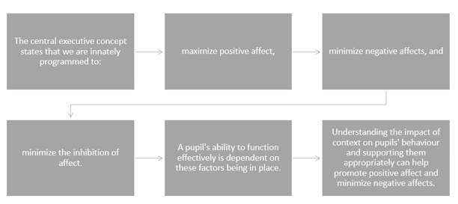

Nathanson's Compass of Shame:
Donald Nathanson, an American psychiatrist, expanded on Tompkins' affect theory by developing the concept of the’ compass of shame’. This model describes four common ways in which individuals respond to feelings of shame: withdrawal, avoidance, attack self, and attack others. According to Nathanson, these responses represent maladaptive coping mechanisms that individuals employ to manage their shame. By identifying and understanding a person's shame responses, interventions can be developed to promote healthier ways of coping with and addressing feelings of shame, ultimately improving their emotional well-being and social functioning.

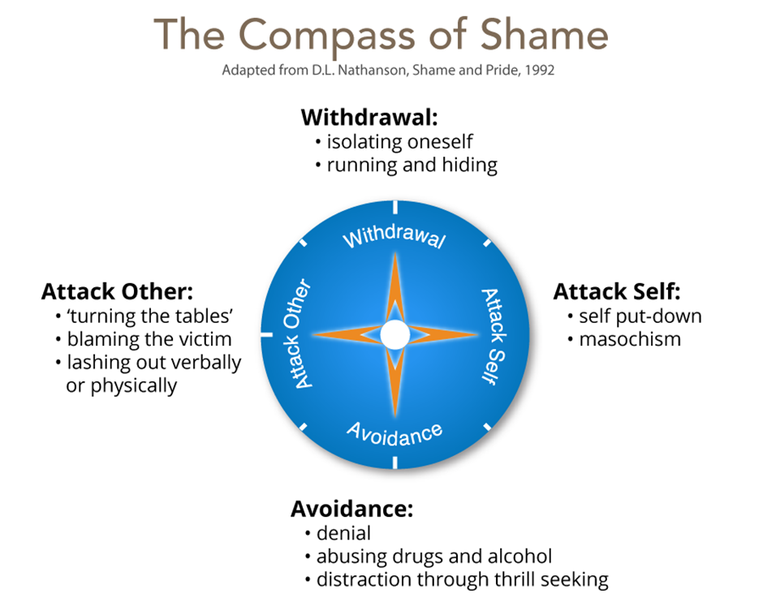

The Role of Context and Biography in presenting behaviour

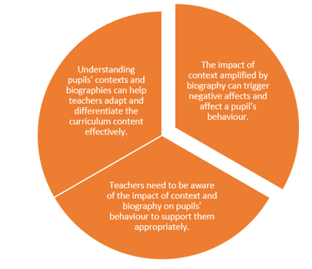

The Educator's Pocket Guide to Understanding Emotions and Behaviour

Understanding Affects: In the world of psychology, 'affects' are the innate drivers of our emotions and behaviours. Think of them as an inner compass, guiding us towards experiences that bring joy and away from those causing discomfort. They're like the engine that powers a car, pushing us towards self-actualisation and the best version of ourselves. Affects are always seeking the joy of discovery, learning, and growth. However, as with any journey, there may be obstacles in the way.

Script Your Emotions: Our emotions and responses are shaped by scripts, just like actors in a play. These scripts, created from our experiences and the people around us, can be encouraging or challenging. They navigate our affects towards the joy of achievement or the fear of failure. As educators, we are instrumental in influencing these scripts. We can serve as torchbearers, guiding students out of the dark forest of negative emotions and towards the treasure of positive ones.

The Weight of Shame: One such obstacle can be the heavy monster of shame. More than mere embarrassment, shame can feel like a deep, inescapable hole. Shame comes when our affects are blocked, when the joy of discovery turns into the fear of failure. This understanding is like learning how to switch on a light in a dark room. By doing so, we can help students shrink the shame monster, teaching them that it's okay to ask for help, and providing them with a ladder to rejoin their peers in the sunshine.

The Motivational Wizard: Our brains function like magical wizards, guided by a compass pointing towards positive emotions (the treasure) and away from negative ones (the thorny path). This compass, also known as the central executive, follows four basic rules that strive to maximise our innate motivation (affect) towards positivity and growth. As educators, understanding these rules equips us with the tools to navigate our students' emotional landscapes, helping us create effective strategies for emotional regulation.

Navigating the Shame Compass: Donald Nathanson, an expert on emotions, described the four common ways people react to shame: withdrawal, avoidance, attack self, and attack others. These reactions can often serve as coping mechanisms when our innate motivation (affect) to strive for joy and growth is blocked. However, they can sometimes make the situation worse, like a compass spinning out of control. By understanding the corners a student tends to choose when their affects are blocked, we can help them find healthier ways to manage their emotions and make their compass point back towards growth and positivity.

Remember, understanding affects and their role in motivation, emotional scripts, the weight of shame, and the corners of shame can help us as educators to create a safe environment where students can learn, grow, and overcome their personal challenges. Our goal should always be to clear the path of their journey towards self-actualisation, no matter how many obstacles stand in their way.

